Skylar Wurster

CSE 5544

Professor Jian Chen

February 14th, 2019

Assignment 3 Design

**Task:** Create a visualization that allows for a general overview allowing for a user to make out some correlations through interaction.

**Design:**

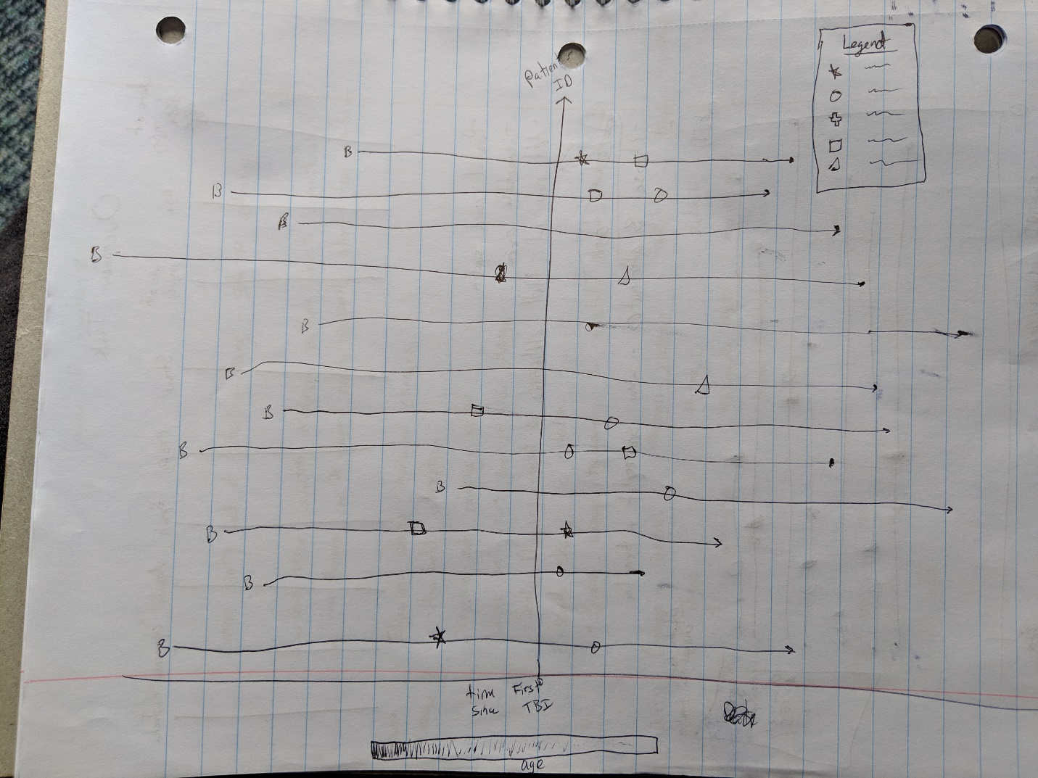

**Analysis:**

Our design demonstrates changes in diagnosis over time for each patient using a type of Gantt Chart. Each patient will have their own bar in the visualization with glyphs on the bar indicating a change in diagnosis. We chose a Gantt Chart due to the ability to compare diagnoses between patients in an interactive way, since each patient’s bar will be able to be moved vertically. This also allows a viewer to make out similarities between patients since similar shapes are easy to pick out to the eye. Through our legend, we allow users to select and deselect which diagnoses are shown (anxiety, depression, PTSD, etc.). This should allow the users to isolate a small number of diagnoses to see rough correlations. The decision for the Gantt Chart was made when we realized the dataset, though large, only contains less than 50 unique patient ID’s.

The x-axis is time, with the origin of the graph being the time of the first TBI. This way, all diagnoses after the TBI can be compared easier for the viewer to make rough correlations. This is aided by the interactive legend.

The y-axis is for each patient. As stated, each patient’s bar can be dragged and positioned at a different vertical position to allow a user to compare a small subset of patients easily.

The bars of the patients themselves will be color coded to show age. For instance, the age group 0-20 would be red, 20-30 would be orange, 30-40 would be yellow, and so on. These are solid colors and not a gradient. This allows the viewers to take age into account in their overview if they so choose. Mousing over a bar at a certain point shows the age of the user at that point, along with days until/since the TBI. If the user hovers over one of the glyphs, all information about that entry is shown in a small pop up box.

With this method, we include every attribute of each data entry aside from data we are unfamiliar with, such as “Type of Injury Code”, “EncounterID”, “Provider_Specialty”, “Provider_type”, and “Product_Line”, in the static view of the visualization. Upon interaction, more details and specific quantities are shown. This serves to compress the EHR spreadsheet into a single computer screen visualization for quick overviews, while allowing viewers to see temporal change not only at an individual level, but also see the correlations.